**Assignment 3** - SoloLearn 14-25 Lessons

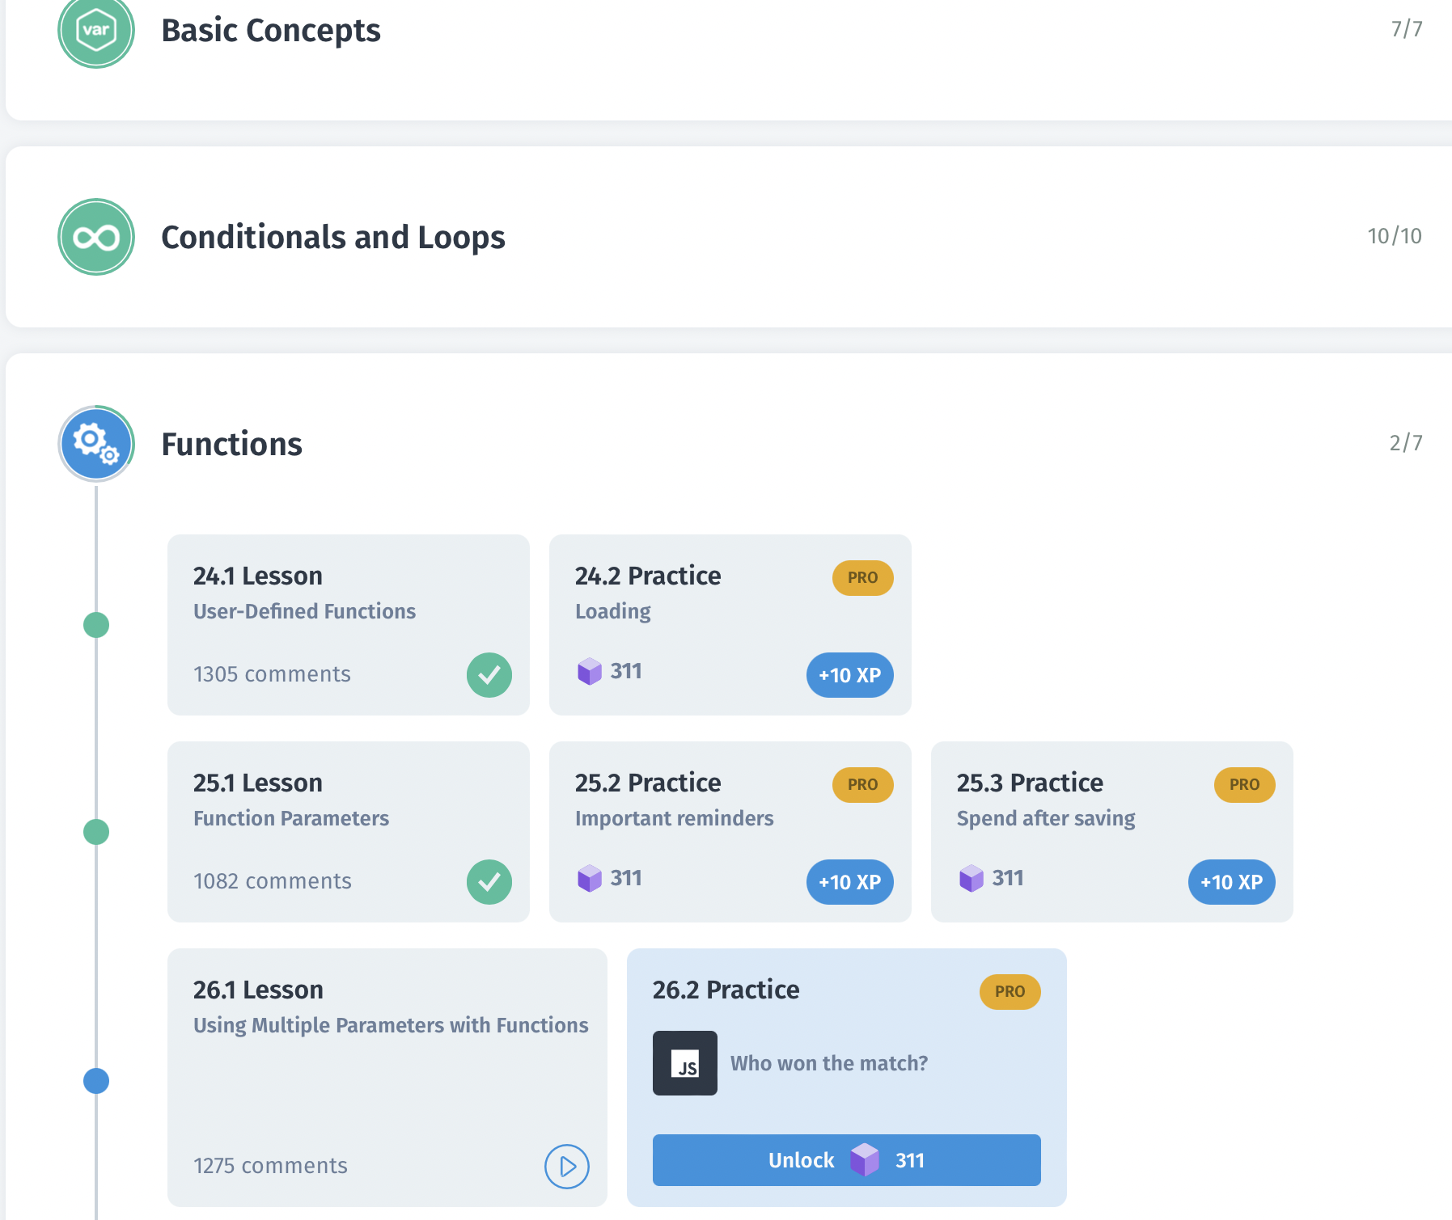

Lesson 14-25 contains three concepts: Conditional Statements, Loops and Functions. Conditional statements are completely dependent on conditions, which evaluates to boolean and if a condition is ‘true’ the statement executes the instructions inside the ‘if ' block otherwise the given ‘else’ block will be executed. Conditional Statements run once only according to condition. However Loops have initialization and a condition, it executes the body statements until the evaluation of a condition is “true”. There are 3 loops: for(statement1; statement2; statement3) {body} - FOR LOOP, while(condition) {body} - WHILE LOOP and do {body} while (condition) - WHILE LOOP. As well as functions render repeatability of instructions with different input values: syntax - function function_name() {body}.

**soloLearn 19.2 Practice Pro**

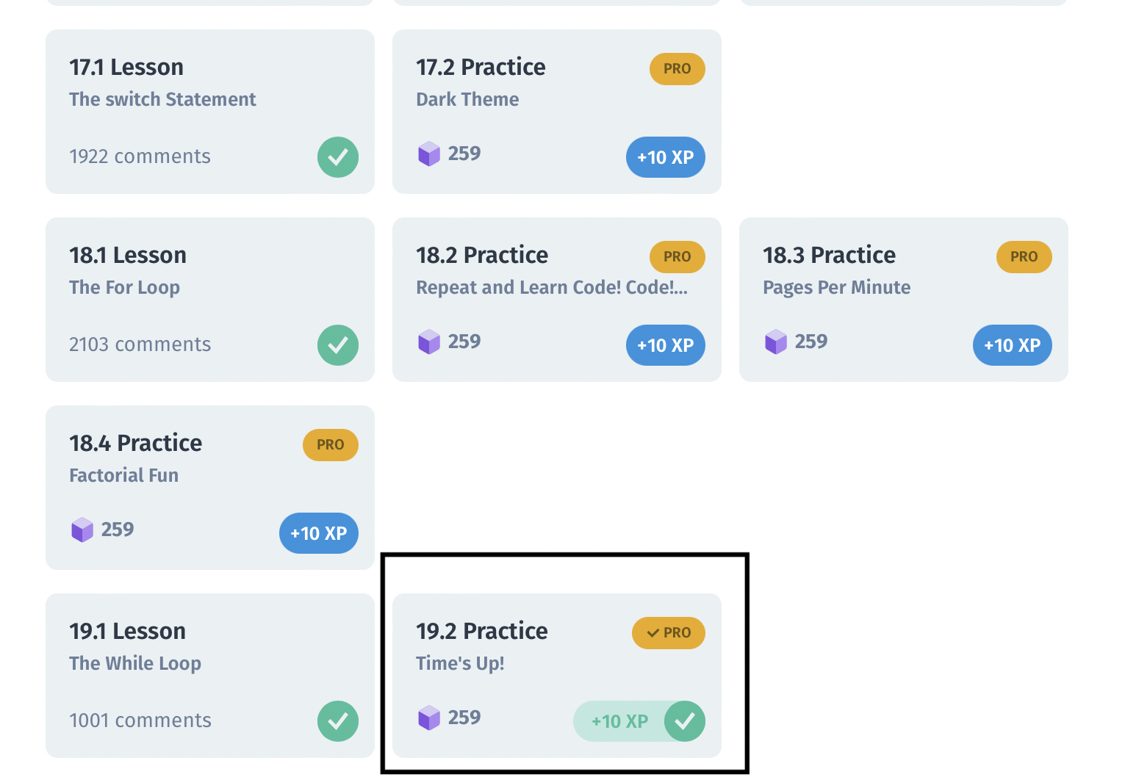

**Problem:**

Input: 4

Output: 4

3

2

1

0

**Solution:**

Here the problem is required to print all decremented integers till 0 from given input.

We need to print an output to console repetitively, therefore use of for loop become obvious,

for (i=input; i<=0; i–) {

console.log(i)

}